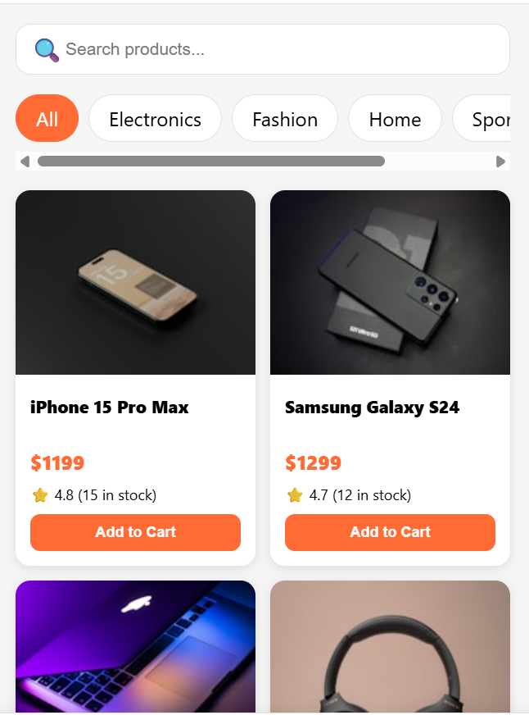
Figure 1:Front page of the app


Figure 2:The tabs section

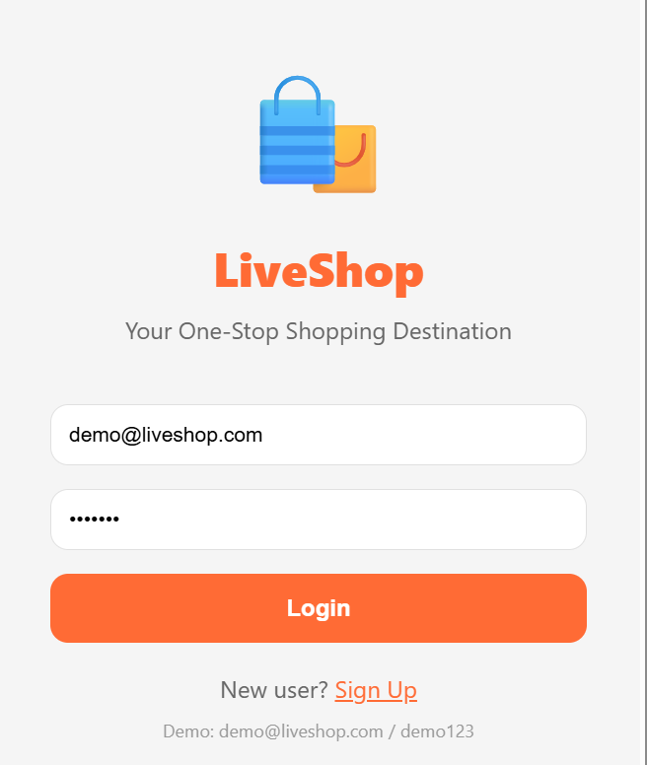
Figure 3:Log-In page
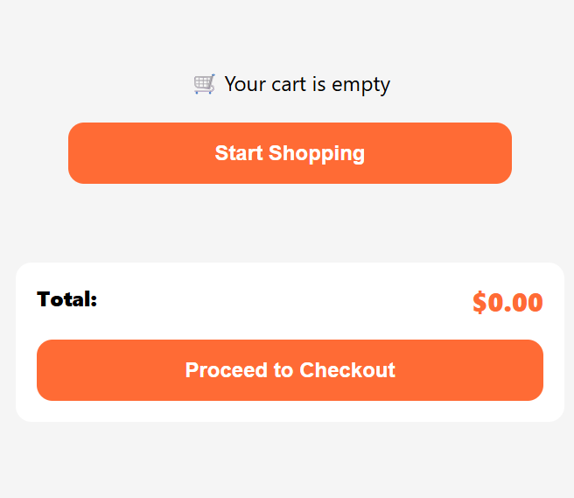
Figure 4:The check-out
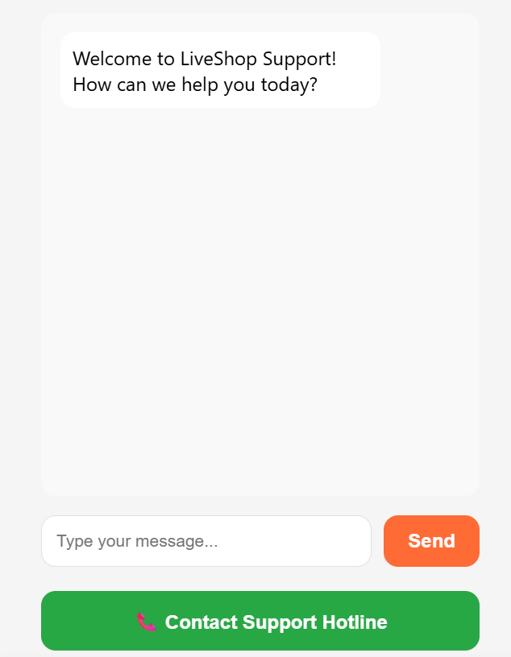
Figure 5:The support tab

